Vectors - Questions
June 2017 Mathematics Advanced Paper 1: Pure Mathematics 4

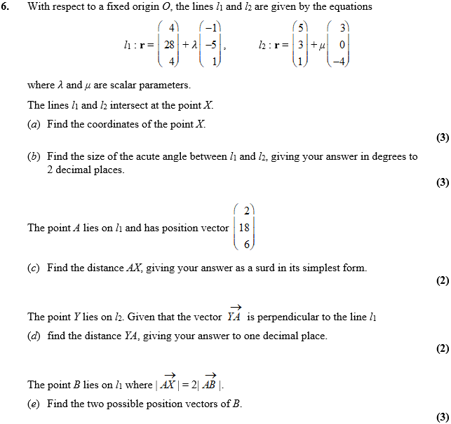

June 2016 Mathematics Advanced Paper 1: Pure Mathematics 4

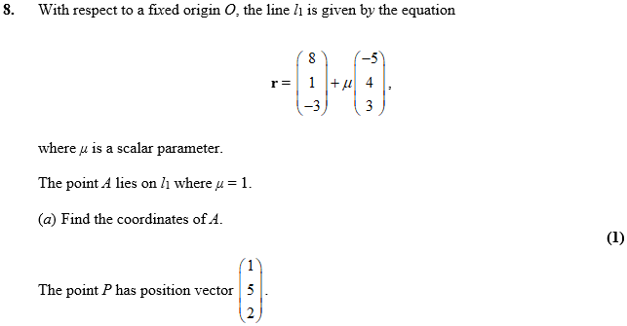
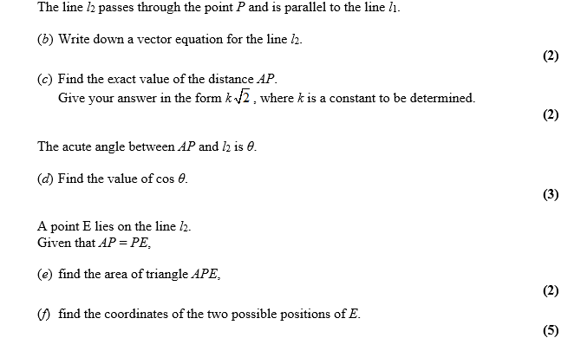

June 2015 Mathematics Advanced Paper 1: Pure Mathematics 4

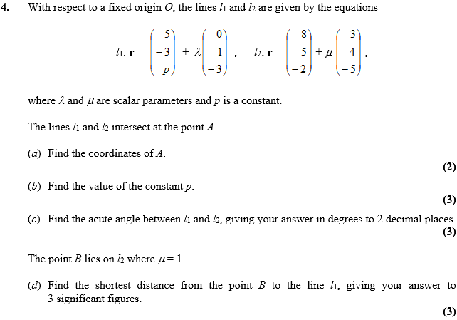

June 2014 Mathematics Advanced Paper 1: Pure Mathematics 4

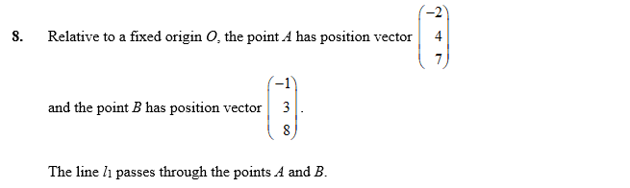
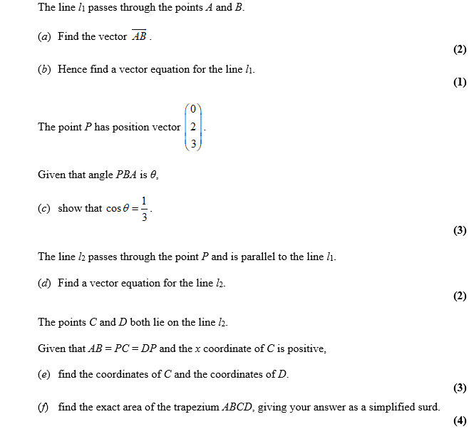

June 2013 Mathematics Advanced Paper 1: Pure Mathematics 4

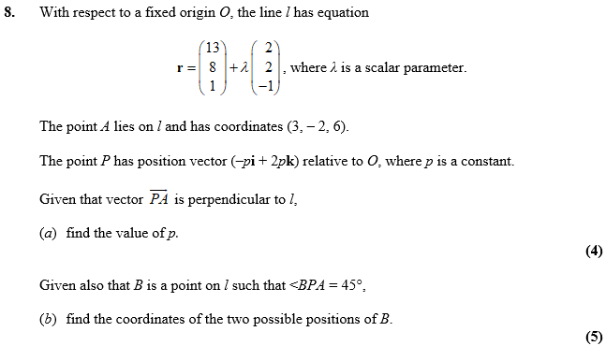

June 2012 Mathematics Advanced Paper 1: Pure Mathematics 4

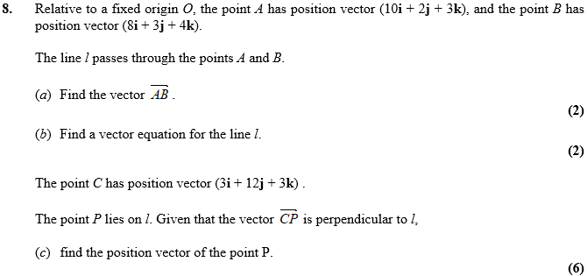

Jan 2012 Mathematics Advanced Paper 1: Pure Mathematics 4

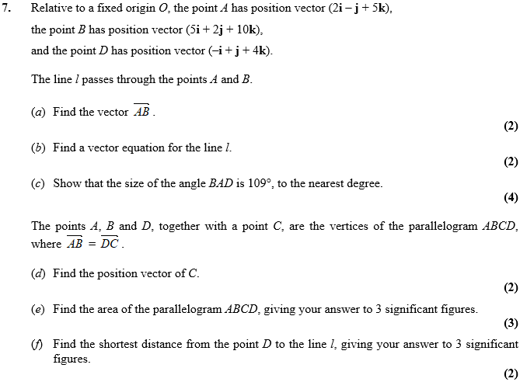

June 2011 Mathematics Advanced Paper 1: Pure Mathematics 4

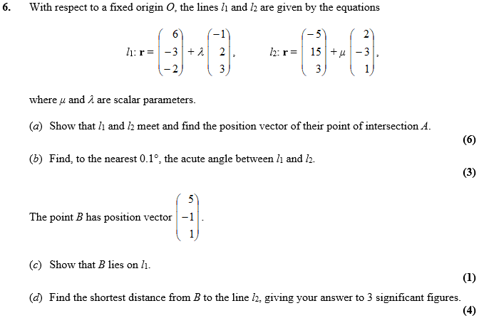

Jan 2011 Mathematics Advanced Paper 1: Pure Mathematics 4

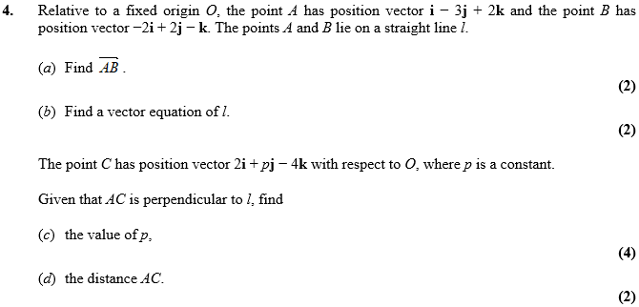
June 2010 Mathematics Advanced Paper 1: Pure Mathematics 4

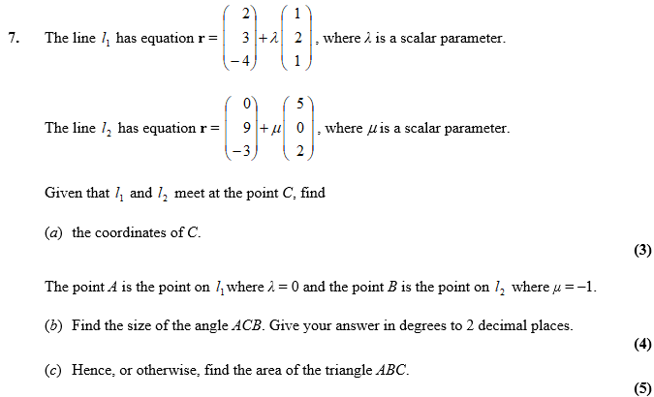
Jan 2010 Mathematics Advanced Paper 1: Pure Mathematics 4

